# SVN Configuration using GitHub

1. Select a physical location – to be used as project workspace   
   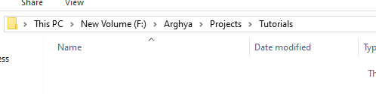
2. Write clicking over empty location select “**SVN Checkout…**”  
   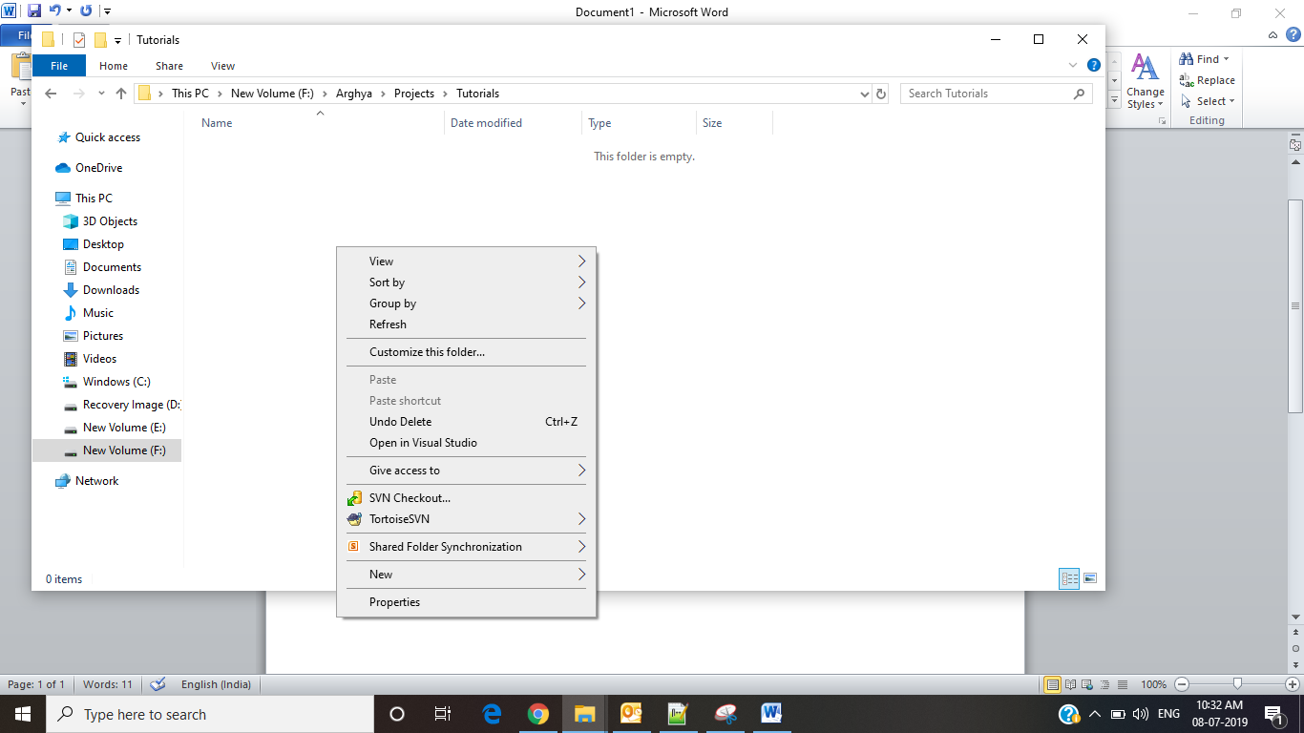
3. Add [**https://github.com/arghyabiswas/tutorials.git**](https://github.com/arghyabiswas/tutorials.git) under URL   
   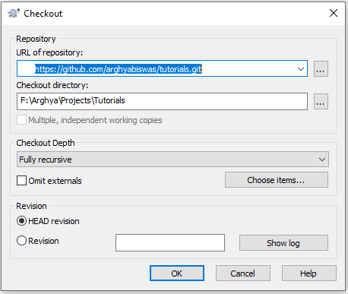
4. Successful Message like the following will be displayed  
   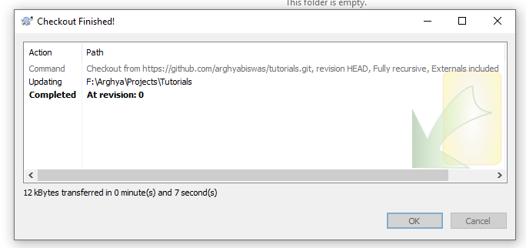
5. Click on “OK”

# Add Item to SVN

1. Select the file or folder to add under repository  
   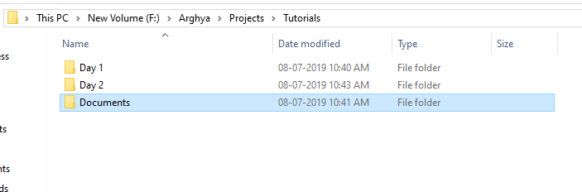
2. Write click over the folder/file select “TortoiseSVN” >> “Add”  
   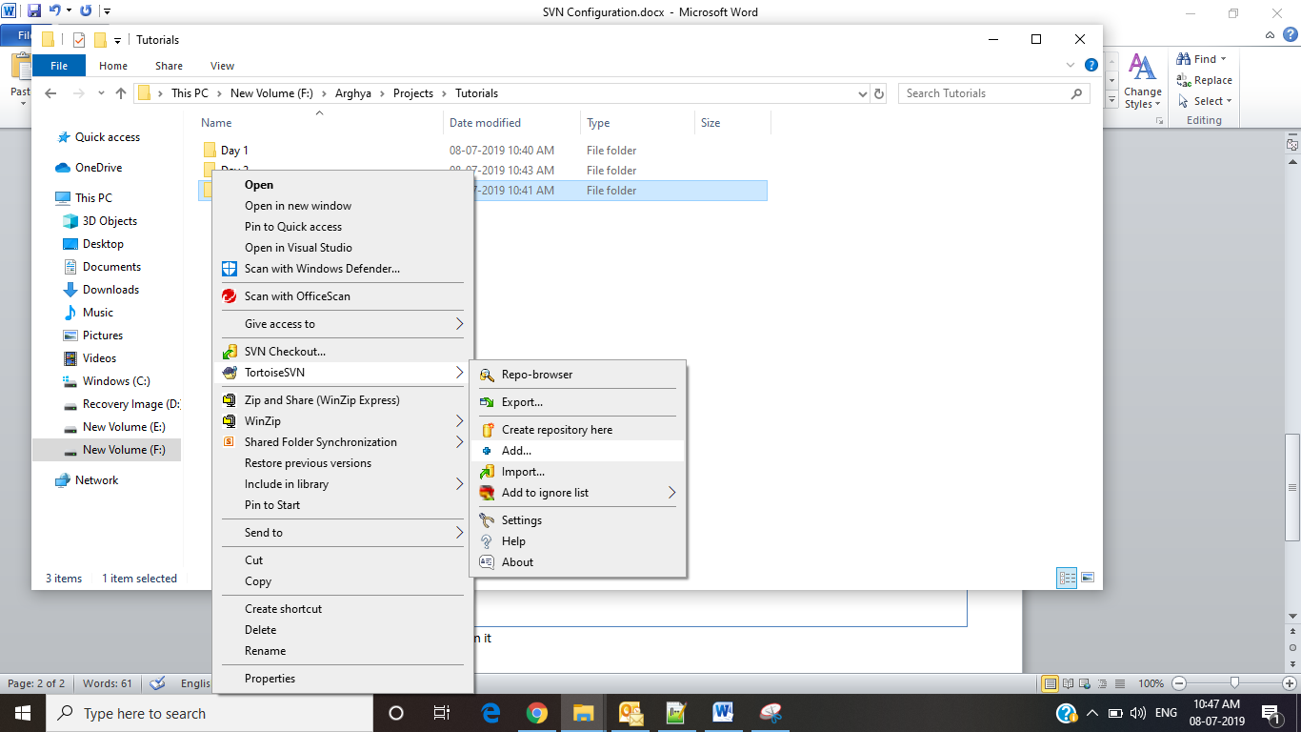
3. Select necessary file or folder to be added, unselect unnecessary files.   
   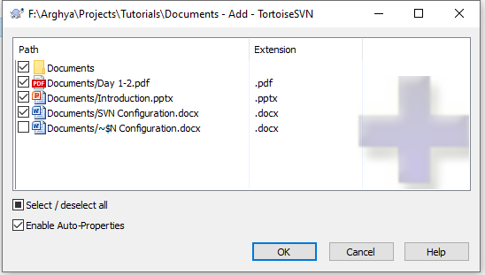  
   **Note: We should not add any EXE/DLL under repository**
4. Click “OK”
5. A confirmation message like the following will be displayed  
   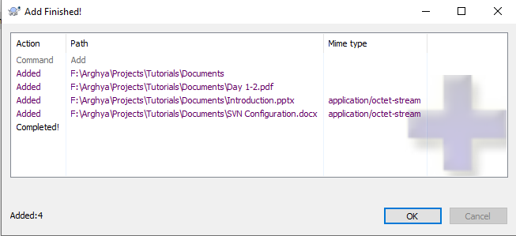
6. Once added the icon of folder will be changed   
   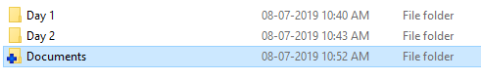  
   **Note: Adding dose not ensure the file is uploaded to server(GitHub)**
7. Write click over the file/folder select “**SVN Commit**…”  
   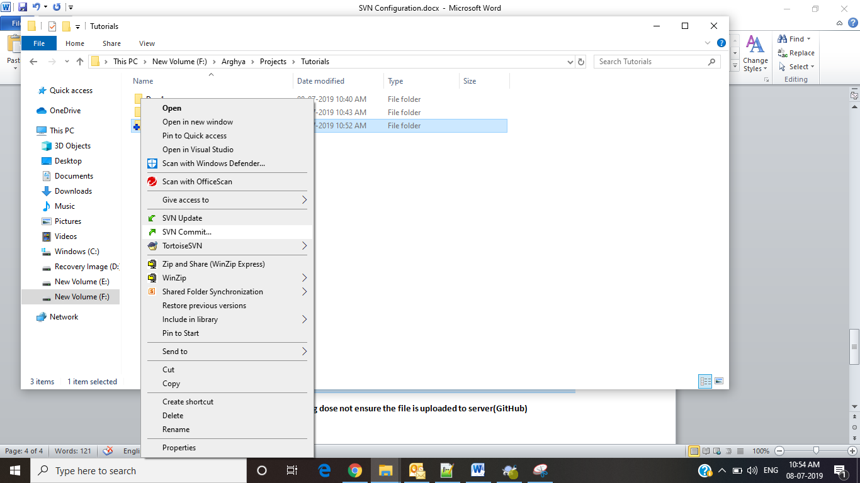
8. An window like the following will be open,   
   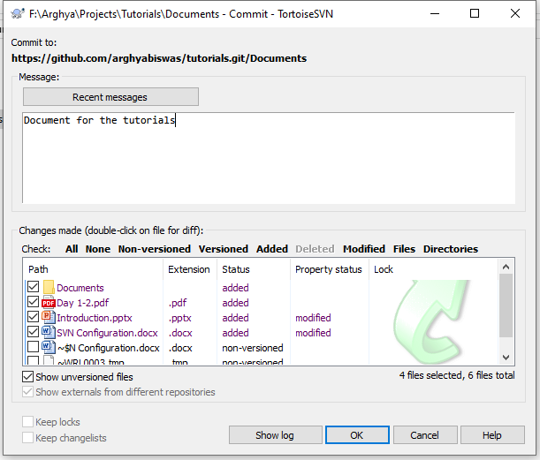
9. Write your comments under “Message box” and click on “OK”
10. This will prompt for authentication, If you don’t have **GitHub** account, create one for your use.  
    